Data Warehousing with IBM Cloud Db2 Warehouse

**Phase 4:**Development part 2

**Tittle:**Continue building the data warehouse by implementing ETL processes and enabling data exploration,

Implement ETL processes to extract, transform, and load data into the data warehouse.Enable data architects

to explore and analyze data within Db2 Warehouse using SQL queries and analysis techniques.

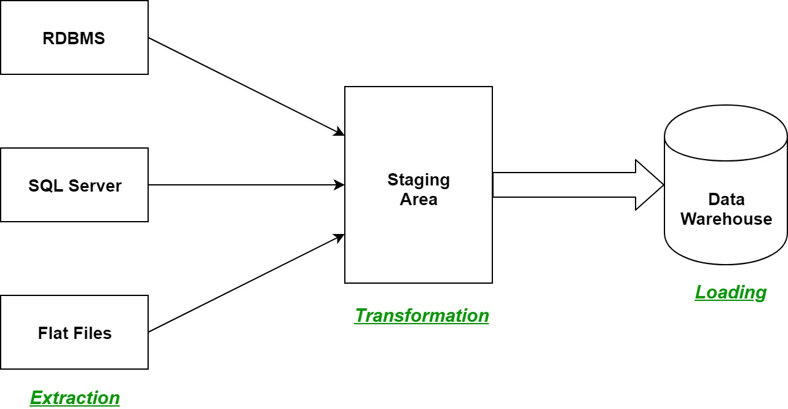

**Data Extraction (E):**

Extract data from various sources such as databases, spreadsheets, APIs, or any other structured or unstructured data repositories.

**Data Transformation (T):**

Transform the extracted data to fit into the data warehouse schema. This step includes cleaning, validating, and structuring the data to make it consistent and usable. You might also perform operations like data enrichment, aggregation, or merging datasets from different sources.

**Data Loading (L):**

Load the transformed data into the data warehouse. Choose an appropriate method for loading data, such as batch processing or real-time streaming, depending on your business requirements.

**Data Exploration:**

Enable data exploration tools and techniques for users to analyze the data easily. This could involve setting up data visualization tools, business intelligence platforms, or even custom dashboards tailored to your organization's needs. Users should be able to query the data, generate reports, and gain insights without requiring extensive technical knowledge.

**Data Governance and Security**:

Implement proper data governance policies to ensure data accuracy, consistency, and security. Define access controls and permissions to restrict data access based on roles and responsibilities. Regularly audit and monitor user activities to maintain data integrity.

**Monitoring and Optimization:**

Set up monitoring tools to track the performance of ETL processes and data exploration queries. Monitor system resource usage, query execution times, and data loads. Use this information to optimize your processes for efficiency.

**Documentation and Training**:

Document the ETL processes, data models, and any custom code or configurations. Provide training sessions for users and data analysts to effectively use the data warehouse and exploration tools.

The specific tools and technologies use will depend on organization's requirements and budget. Common ETL tools include Apache Airflow, Talend, and Informatica, while popular data exploration tools include Tableau, Power BI, and Google Data Studio. Always tailor your approach to best suit your organization's needs.

**Identify Data Source:**

List all the devices and sensors from which you intend to collect data. This could include temperature sensors, GPS devices, industrial machinery, or any other IoT devices.

**Data Collection**:

Determine how data is collected from these devices. Some devices may transmit data through APIs, while others might use standard communication protocols like MQTT, CoAP, or HTTP.

**Data Ingestion:**Choose an appropriate method to ingest data from devices into your data warehouse. This could involve setting up data ingestion platforms or tools that can handle various data formats.

**Real-time Data Processing**:If real-time data is critical for your project, consider using real-time data processing technologies such as Apache Kafka, Apache

Flink, or AWS Kinesis to handle streaming data from devices.

**ETL Processes**:Integrate the device data into your ETL (Extract, Transform, Load) processes, which may involve using ETL tools and frameworks. These processes will ensure that device data is structured and integrated with other data sources.

**Data Governance and Security**:Implement data governance and security

measures to protect device data. This includes encryption, access control, and auditing.

**Data Catalog and Metadata Management**:Include device data in your data catalog and metadata management system. This will help users discover and understand the available device data assets.

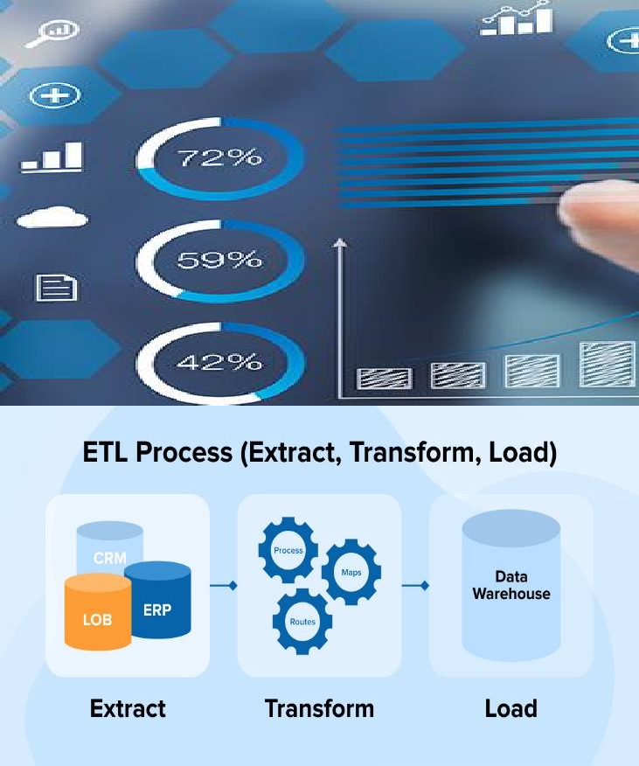

**Error Handling:** Develop strategies to handle errors during extraction, transformation, or loading processes.

Monitoring: Set up monitoring and alerting systems to detect failures and performance issues.

**Testing and Validation:**Unit Testing: Test individual components of the ETL process to ensure they function as expected.

Integration Testing: Test the entire ETL workflow to validate data flow and transformations.

**Validation:** Validate the loaded data against the source to ensure accuracy.

**Scheduling and Automation:**Scheduling: Schedule ETL jobs at appropriate times to avoid impacting the performance of source systems.

**Automation:** Automate the ETL process to run at scheduled intervals without manual intervention.

**Documentation:** Document the ETL process, including data mappings, transformations, and schedules.

**Maintenance:** Regularly update and maintain the ETL processes as new data sources or business requirements emerge.

The specific tools and technologies you use for ETL processes can vary based on your organization's requirements and preferences. Always ensure data security and compliance with relevant regulations during the ETL process

**Connect to Db2 Warehouse:**

Use a SQL client or command-line interface to connect to the Db2 Warehouse database. Provide the necessary connection credentials like hostname, port, database name, username, and password.

**Understand the Database Schema:**

Familiarize yourself with the structure of the database, including tables, columns, and relationships. This knowledge is crucial for formulating effective SQL queries.

**Write SQL Queries:**

Use SQL queries to retrieve, filter, and analyze data. For example:

sql

Copy code

SELECT column1, column2 FROM table\_name WHERE condition;

**Aggregate Data:**

Utilize aggregate functions (e.g., SUM, AVG, COUNT) to analyze data at a higher level.

sql

Copy code

SELECT SUM(sales) AS total\_sales FROM sales\_data;

**Join Tables:**

Combine data from multiple tables using JOIN operations to perform more complex analysis.

sql

Copy code

SELECT [customers.name](http://customers.name/" \t "https://mail.google.com/mail/u/1/" \l "inbox/_blank), orders.order\_date

FROM customers

INNER JOIN orders ON [customers.id](http://customers.id/" \t "https://mail.google.com/mail/u/1/" \l "inbox/_blank) = orders.customer\_id;

**Use Subqueries:**

Subqueries can be nested within other queries and are useful for performing operations on intermediate results.

sql

Copy code

SELECT product\_name

FROM products

WHERE category\_id IN (SELECT category\_id FROM categories WHERE category\_name = 'Electronics');

Optimize Queries:

Write efficient queries to improve performance. Use indexes on columns frequently used in search conditions.

Perform Data Analysis:

Utilize statistical functions and analysis techniques to gain insights from the data.

sql

**Copy code**

SELECT AVG(salary), MAX(salary), MIN(salary)

FROM employees

WHERE department = 'Sales';

Visualize Data:

Use visualization tools or integrate SQL queries with data visualization libraries to create charts and graphs for a better understanding of the data.

Document Findings:

Document query results, analysis methods, and insights obtained from the data. Proper documentation ensures that findings are clear and can be shared with stakeholders.

practicing different types of queries and analysis techniques will enhance the data architect's proficiency in exploring and analyzing data within Db2 Warehouse.

**Source code:**

import java.sql.Connection;

import java.sql.DriverManager;

import java.sql.PreparedStatement; import java.sql.ResultSet;

import java.sql.SQLException; import java.sql.Statement;

public class Db2WarehouseExample { public static void main(String[] args) {

// Replace with your IBM Cloud Db2 Warehouse connection details

String jdbcUrl =

"jdbc:db2://<your\_hostname>:<your\_port>/<your\_database\_name>"; String username = "<your\_username>";

String password = "<your\_password>";

Connection conn = null;

try {

conn = DriverManager.getConnection(jdbcUrl, username, password); System.out.println("Connected to the database");

Statement stmt = conn.createStatement(); String createTableSQL = "CREATE TABLE Sales ("

+ "OrderID INT, "

+ "ProductID INT, "

+ "OrderDate DATE, "

+ "Quantity INT, "

+ "Price DECIMAL(10, 2), "

+ "CustomerID INT, "

+ "TotalAmount DECIMAL(10, 2))"; stmt.execute(createTableSQL);

System.out.println("Table 'Sales' created");

String loadCSVSQL = "LOAD FROM 'your\_local\_path/sales\_data.csv' OF DEL INTO Sales";

stmt.execute(loadCSVSQL);

System.out.println("Data loaded from CSV");

String transformDataSQL = "UPDATE Sales SET TotalAmount = Quantity \*

Price";

stmt.execute(transformDataSQL);

System.out.println("Data transformed");

String query = "SELECT CustomerID, SUM(TotalAmount) AS TotalSales

FROM Sales GROUP BY CustomerID";

ResultSet resultSet = stmt.executeQuery(query); while (resultSet.next()) {

int customerID = resultSet.getInt("CustomerID"); double totalSales = resultSet.getDouble("TotalSales");

System.out.println("CustomerID: " + customerID + ", TotalSales: " + totalSales);

}

} catch (SQLException e) { e.printStackTrace();

} finally {

if (conn != null) { try {

conn.close();

} catch (SQLException e) { e.printStackTrace();

}

}

}

}

}

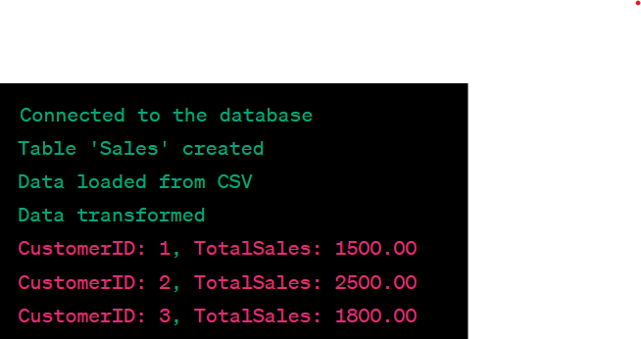



Output:

CONCLUSION:

In the building and maintaining a data warehouse is a comprehensive and dynamic project that requires careful planning, ongoing attention, and a commitment to data quality and security. When executed effectively, a data warehouse can serve as a valuable asset, supporting informed decision-making and data analysis across an organization.